Purpose
The purpose of this procedure is to provide guidance on the preparation of Employee Provisions liability of Wannon Water.

Scope
This procedure is administered by the Financial Controller.

Procedure
Employee Leave Balances

Remuneration Co-ordinator shall provide base line worksheets which detail all employee leave balances as at the end of the reporting period. Balances shall be provided for the following:

- Annual Leave
- Long Service Leave
- Rostered Days Off
- Other Leave

Rate of Remuneration

The employee rate of remuneration is required to be grossed up to include the cost of superannuation and the WorkCover premium.

Worksheet Preparation

Annual Leave

Individual employee balances as at the report balance date are multiplied by the employee’s grossed up hourly rate to calculate Wannon Water’s total Annual Leave liability.

Long Service Leave

Under the current Wannon Water EBA, Long Service Leave is vested after 7 completed years of service.

Long Service Leave, due to its nature of not being available until after a certain period of service, has to be calculated by applying discount and probability factors of the employee actually reaching service levels that shall see the liability becoming vested.

Rostered Days Off

Individual employee balances as at the report balance date are multiplied by the employee’s grossed up hourly rate to calculate Wannon Water’s total Rostered Days Off liability.

Other Leave

This category of leave includes accrues time in lieu. Individual employee balances as at the report balance date are multiplied by the employee’s grossed up hourly rate to calculate Wannon Water’s total Other Leave liability.

Manual Procedure to work out Provisions

Remuneration Co-ordinator emails Leave Liability report file (LL report) dated the last pay period in the month (see figure 1)

Figure 1 (LL report)
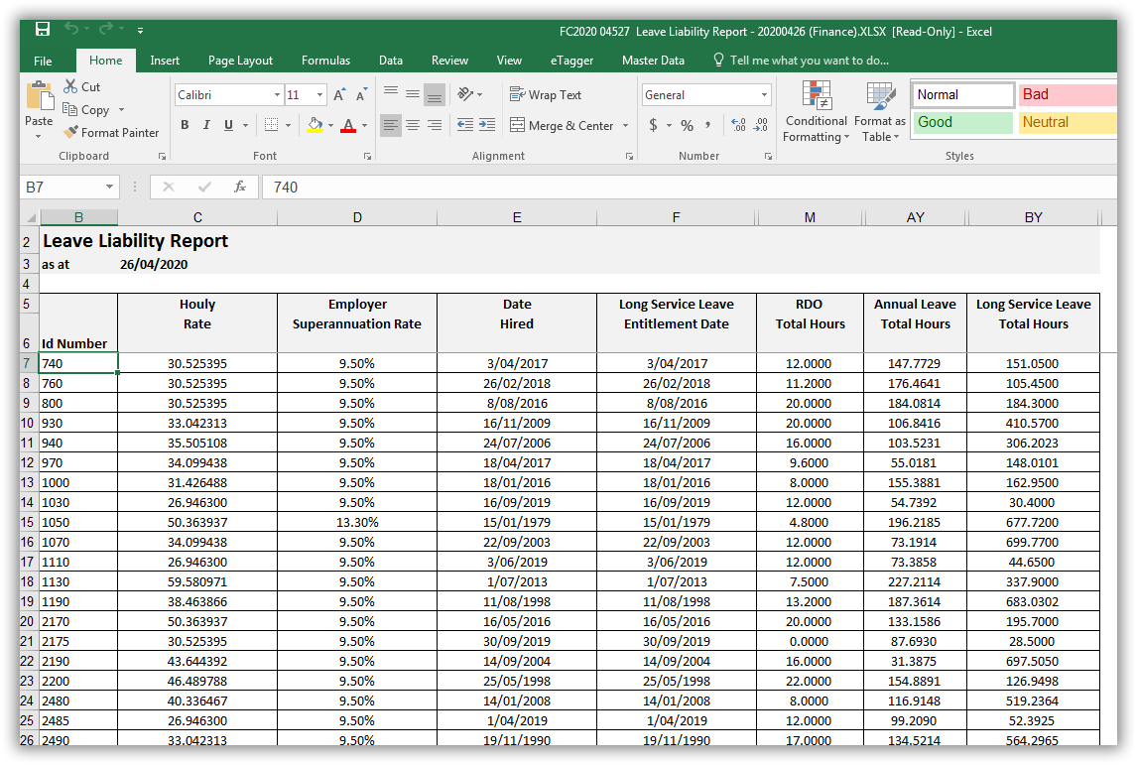

Save this document as a follow up document to the General Ledger Reconciliation monthly document in Content Manager (CM) Records Management system.

Open the Leave Liability worksheet file (LL worksheet) from the same location for the previous month and save as the current month in the same folder (see figure 2).

Figure 2 (LL Worksheet)
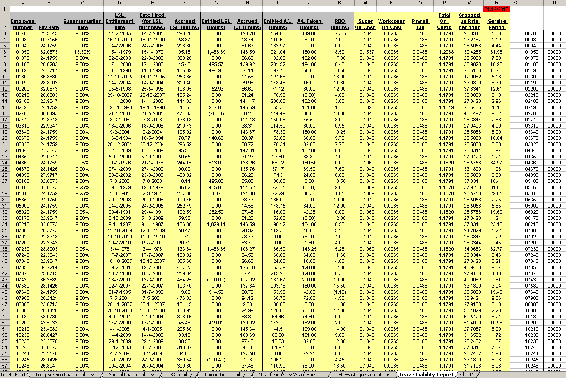

In the LL worksheet file within the Leave Liability Report worksheet, change the date at cell R1 to the end of the month.

Compare the LL report and the LL worksheet to ascertain movements in employees for the month. To do this, paste the employee number list from column B in the LL report file to column T within the Leave Liability Report worksheet. Where there is a variance from 0 in column U alterations are required.
- For negative numbers – insert columns A to R
- For positive numbers – delete columns A to R
- (Make sure you record the employee numbers for the deletions and additions as you are going)

For the inserted employees, type in their employee number into column A and then update columns M to R in Leave Liability Report worksheet for new employees with formulas from cells above.

Once all deletions and new employees have been entered:
Copy and paste values of all of columns C and D in LL report to columns B and C in Leave Liability Report worksheet.

Copy and paste values of all of column E of LL report to columns D and E in Leave Liability Report worksheet.

Copy and paste values for all of LSL (Hours), Annual Leave (Hours) and RDO (Hours) from LL report to LL worksheet.

In LL worksheet hold the control key and select the first 4 worksheets (from Long Service Leave Liability to Time in Lieu Liability) then go ahead and insert and copy down from row above for the new employees and delete the employees that have left by using the list of employee numbers recorded earlier.

Check the totals balance from all the worksheets at the bottom of the Leave Liability Report worksheet.

Go to Number of Employee worksheet and delete old and add new employees from recorded list. The totals at the bottom of column AC should balance and the sheet is set up to inform whether the process has balanced at the bottom of column F.

Open the previous months DTF LSL Model 2008. Click the start 7yrs LSL button. Click on the Next Quarter button at the end of each Quarter. Fill in the data in cells F12 and cells F18 to F24 with the numbers from the bottom of the Number of Employees worksheet for years 1 to 6 and then from years 7+. Make sure amount in cell F28 in model balances with the total cell at bottom of Number of Employees worksheet in column F. Click the Next Step button.

Each quarter, the Department of Treasury and Finance produce a table of discount factors to be applied in the calculation of Long Service Leave liability at State Government bodies.

Enter the discount factor rates each quarter into the spreadsheet if required and click Calculate PV Liability. (Payroll tax, Work cover and Super are updated annually)

Print screen (after you have changed the date if required) of Wannon Water’s Long Service Leave liability (Table 2.1) and Go To Calc Sheet and change date if required and then print this sheet (Table 2.2)

Click Finish, click Quit the Model and save and this is when you save the document in the correct location (as above) with the correct month in the file name.

Go back to the LL worksheet and print out the first 4 worksheets to go behind the Balance Sheet Recs as well as the Leave Liability Report worksheet.

Enter the Journals in Finance One as required using the employee provision journal worksheet within the Reconciliations workbook and complete the Balance Sheet Recs.

Table 2.1

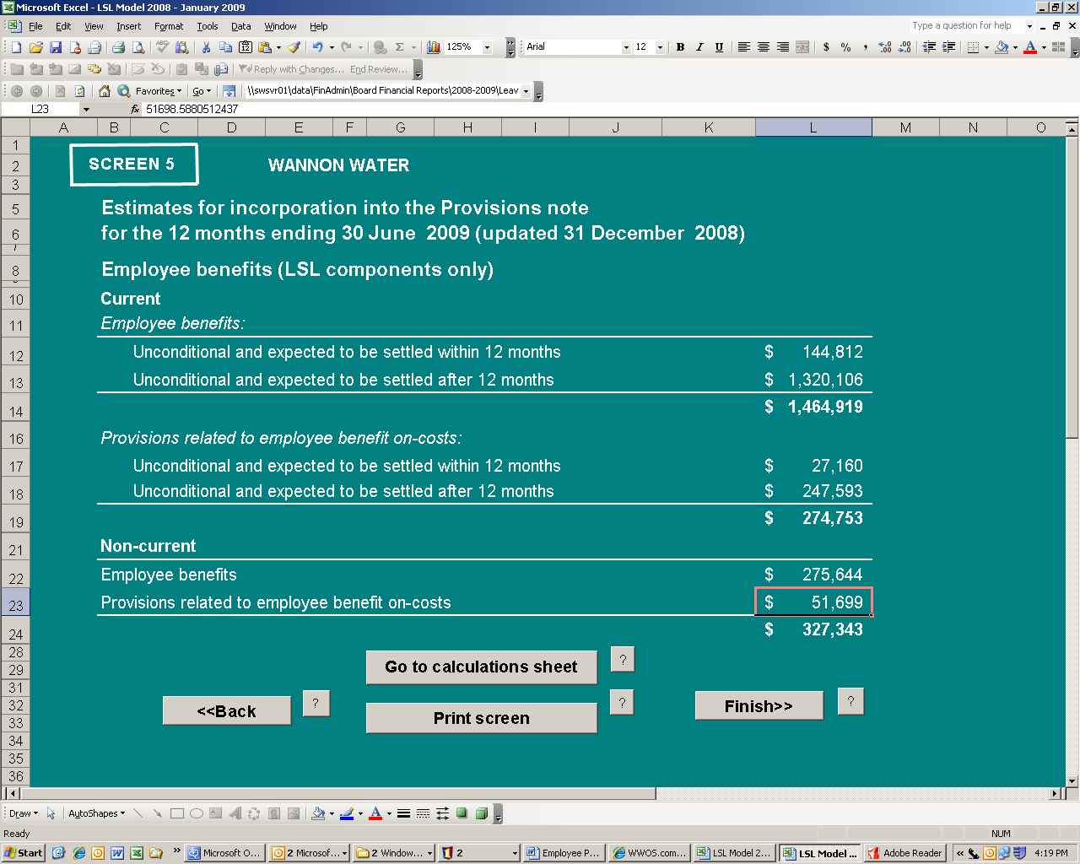

Table 2.2

End of Financial Year Process:

Extra information needs to be provided:

- Contact Payroll as you need to advise the number of employees who have taken their LSL balance with them to their new job, or brought it with them when they started at WW.
- Need to provide LSL paid or taken amounts – go into GL officer – account 7.22.249.1.03.998.00 – filter by HRPAYJNL
Go into the 2008 Long Service Leave Model and click on back

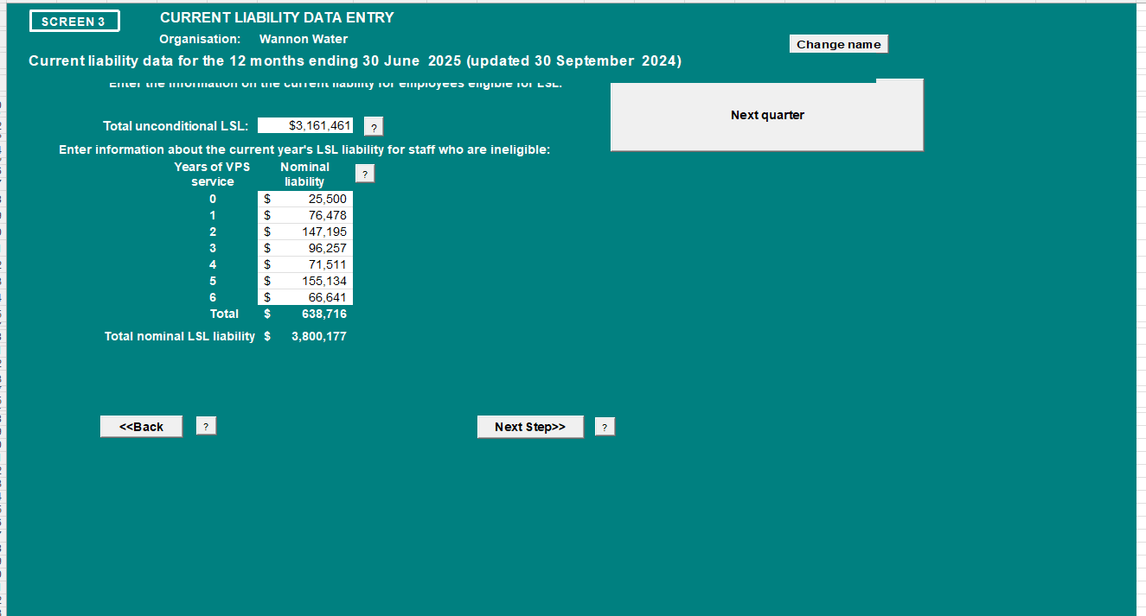

Update the LSL paid/taken section

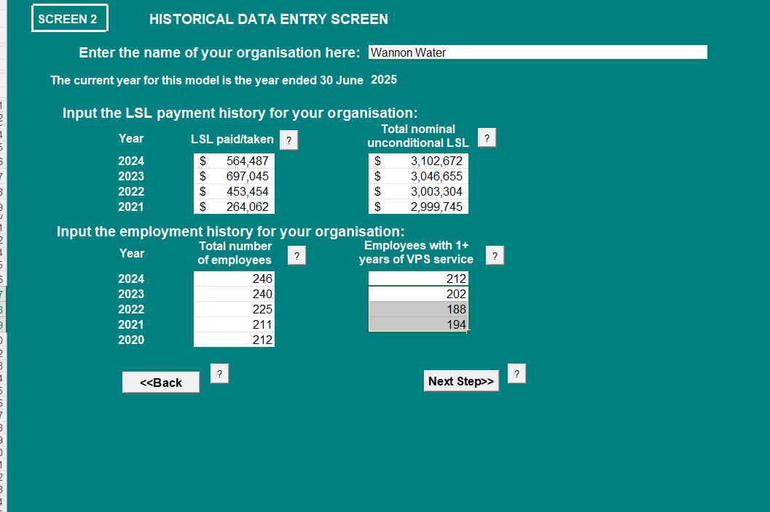

Update the total number of employees and Employees with 1+ years of VPS service (this information is found on the leave liability worksheet)

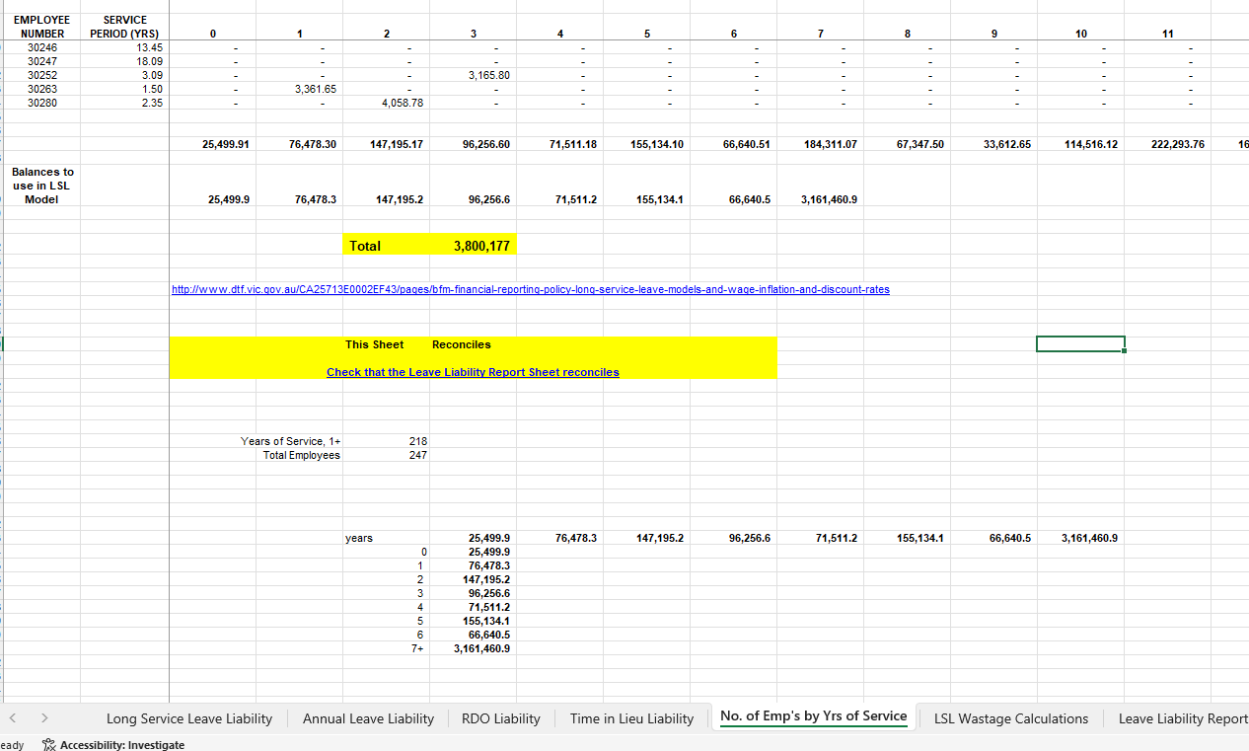

Once you have provided all this information, click on next steps

Then click on Next Quarter to take you to the new financial year (DON’T CLICK ON NEW YEAR)

Roles and responsibilities
Position | Roles and responsibilities
Accounts Payable & Payroll Officer | Applying the procedure and updating end of financial year processes.
Financial Controller | Reviewing and approving the procedure

Definitions
Term | Means
EBA | Enterprise Agreement
LL | Leave Liability
LSL | Long Service Leave

Governance
Parent policy/standard | N/A
Associated procedures/standards | N/A
Relevant legislation | N/A
Approval | Finanicial Controller
Procedure owner | Administration Officer
Content enquiries | Administration Officer

Document version history
Version | Changes made to document
8 | Changed to new template

